Supplementary material for the article *‘A method to assess inter- and intra- vessel shape variation in pottery using GMM’*

**S1. Archaeological Context**

The sample of thirty ceramic vessels consist of artefacts from recently excavated sites in Nariño, Colombia as well as from archaeological pottery collections. The context of each has been described in Klesner et al. (2025) and summarised here.

The excavated material includes samples from **Site 137** in El Porvenir, Iles (Mendoza Acosta & Rubin de Rubin 2021; Mendoza Acosta & Marín 2023) which was excavated in 2019-2020 as part of the preventive archaeological interventions carried out within the Rumichaca-Pasto Road Project (ICAHN registration no. 7610). The site, which is dated to the 4-5th c. AD, is a cemetery, and the tombs only recovered Capulí style ceramics. There was no evidence of looting or high agricultural activity at the site, which resulted in undisturbed tombs with remarkably well-preserved ceramic vessels.

Two different excavations in the municipality of Catambuco are considered in this research. Catambuco is located approximately 4 km south of the major city of Pasto, and the sites are located above 2800 m.a.s.l. **Site 8** was excavated as part of the preventive archaeology study (ICAHN registration no. 4627) of the Rumichaca-Pasto Road Project, and recovered only Piartal style ceramics from a total of eight excavated tombs, three of which were undisturbed.

Adjacent and immediately below Site 8 is the site of **San Damián**, which was excavated as part of a preventive archaeology study (ICANH permit No. 7774 and 8066) for the CESMAG University Institution project. The study area is a large plateau (78,434 m2), which includes domestic, funerary, and ceremonial contexts. Archaeological evidence suggests that the site was primarily associated with Tuza ceramic material, and is related to a late pre-Hispanic occupation.

Lastly the site of **CIAO21** is located on the land of the AGROSAVIA research centre in Obonuco, Pasto excavated in 2021 as part of the “ICAHN Protocol for the Management of Chance Archaeological Finds”. The site consists of just one, exceptional communal tomb that dates from the 11th-12th c. AD. The tomb consisted of fourteen individuals (nine adults and five infants), 59 complete or near complete Piartal style ceramic vessels, along with lithic artifacts, an ocarina, textile fragments, necklace beads, and a sample of ochre pigment.

The excavated material was supplemented with material in the **Museo del Oro** in Bogotá, which has a large corpus of ceramic from the Narino highlands. A second pottery collection, the Hacienda San Antonio de Bomboná Pottery collection (abbreviated to **Bomboná collection**), which is registered with the Colombian Institute of Anthropology and History (ICANH) under the ‘Resolución de tenencia de patrimonio arqueológico colombiano’ (ICANH registration no. 1202), was also examined.

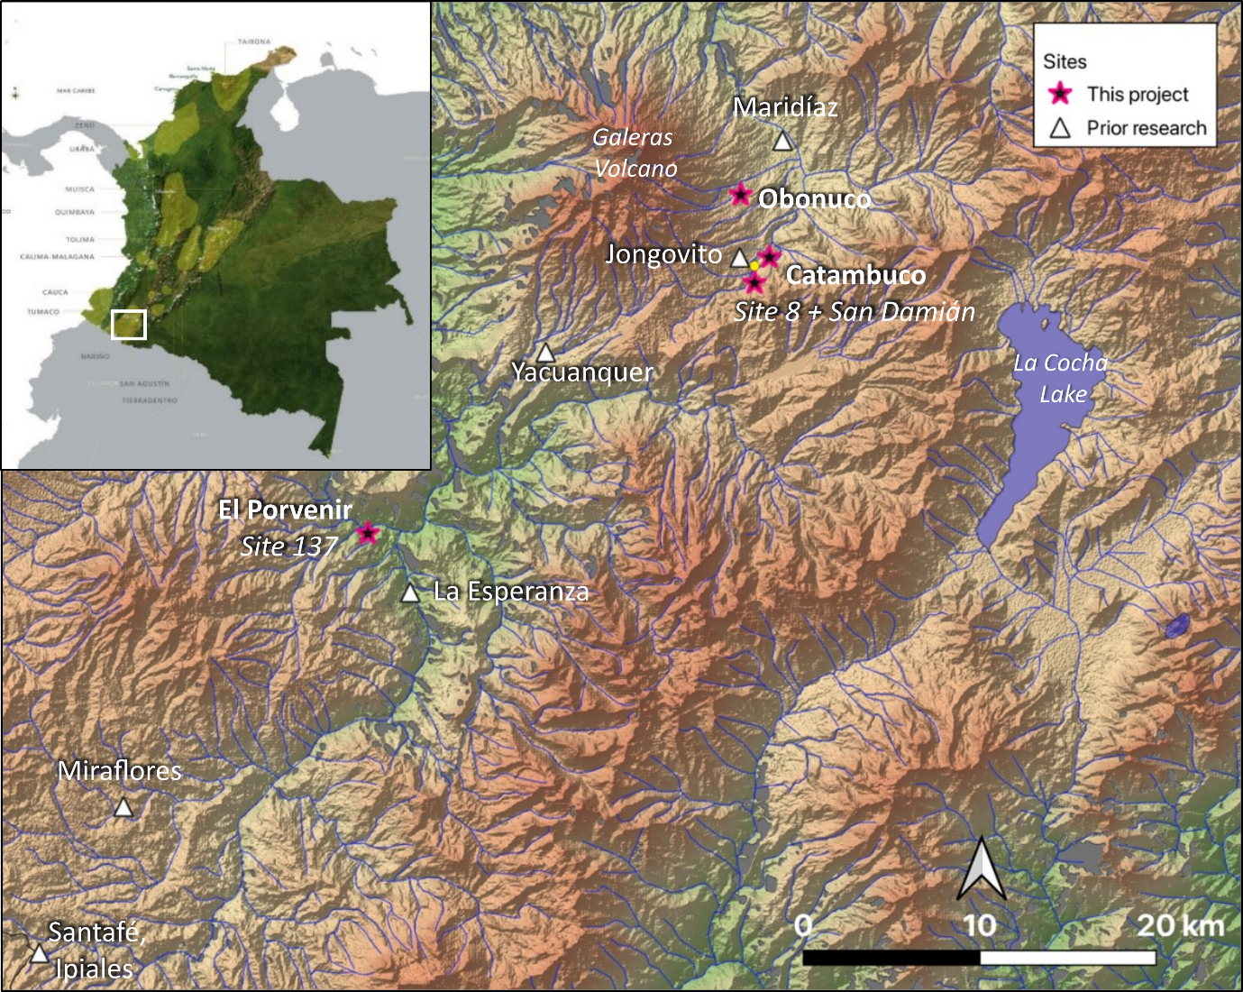**Supplementary Figure 1.** Map of the Serranía nariñense (Colombia) with the location of the sites mentioned in the text indicated. Map drawn in QGIS v. 3.4.4 (QGIS Development Team 2022) with the projection Magna-Sirgas EPSG 4686. Hillshade based on 1 Arc-Second STRM data produced by NASA, with the water bodies taken from Instituto Geográfico Agustín Codazzi (IGAC 2022).

**Supplementary Table 1.** Summary of the samples included in this analysis, including their archaeological context where known.

|  |  |  |  |
| --- | --- | --- | --- |
| **Vessel** | **Ware** | **Collection** | **Context** |
| CA230334 | Capulí | Museo del Oro | None |
| CA230335 | Tuza | Museo del Oro | None |
| CA230337 | Piartal - 2 | Museo del Oro | None |
| CA230347 | Piartal - 2 | Museo del Oro | None |
| CA230348 | Capulí | Museo del Oro | None |
| CA230354 | Tuza | Museo del Oro | None |
| CA230361 | Piartal - 1 | Catambuco - Site 8 | Monitoreo, Tomb 3 |
| CA230365 | Capulí | El Porvenir - Site 137 | Corte 7, Tomb 1 |
| CA230366 | Capulí | El Porvenir - Site 137 | Corte 7, Tomb 1 |
| CA230375 | Capulí | El Porvenir - Site 137 | Monitoreo, Tomb 2 |
| CA230377 | Capulí | El Porvenir - Site 137 | Landslide, Tomb 4 |
| CA230378 | Capulí | El Porvenir - Site 137 | Landslide, Tomb 4 |
| CA230381 | Capulí | El Porvenir - Site 137 | Landslide, Tomb 10 |
| CA230386 | Capulí | El Porvenir - Site 137 | Landslide, Tomb 1 |
| CA230387 | Capulí | El Porvenir - Site 137 | Landslide, Tomb 5 |
| CA230401 | Tuza | Bomboná | Attributed to the Los Eucaliptos homestead |
| CA230404 | Piartal - 2 | Bomboná | Attributed to Aguacate homestead |
| CA230411 | Tuza | Bomboná | Attributed to Aguacate homestead |
| CA230416 | Piartal - 1 | CIAO21 | Obonuco tomb |
| CA230417 | Piartal - 1 | CIAO21 | Obonuco tomb |
| CA230422 | Piartal - 1 | CIAO21 | Obonuco tomb |
| CA230423 | Piartal - 1 | CIAO21 | Obonuco tomb |
| CA230424 | Piartal - 1 | CIAO21 | Obonuco tomb |
| CA230428 | Tuza | Catambuco - San Damián | Rasgo 36, Tomb 18 |
| CA230429 | Tuza | Catambuco - San Damián | Rasgo 95, Tomb 50 |
| CA230430 | Tuza - Red slip | Catambuco - San Damián | Monitoreo |
| CA230715 | Tuza | Museo del Oro | None |
| CA230717 | Piartal - 1 | Museo del Oro | None |
| CA230718 | Tuza | Museo del Oro | None |
| CA230724 | Tuza | Museo del Oro | None |

**S2. Wall-thickness as a proxy for primary forming method**

Two recent publications have presented methods to quantify intra-vessel variation in wall thickness and shape regularity (Thér & Wilczek 2022; Caloi & Bernardini 2024). Both studies have examined open vessel shapes made experimentally by a single, skilled potter employing a range of forming methods (Supplementary Table 2).

**Supplementary Table 2.** Summary of theforming methods, analytical techniques, and measures of variability examined in recent experimental archaeology studies.

|  |  |  |  |  |
| --- | --- | --- | --- | --- |
| **Study** | **Forming methods under investigation** | **Sample size** | **Analytical Method** | **Measure of Variability** |
| Caloi & Bernardini 2024 | Throwing-off-the-hump  Wheel-throwing from a solid ball of clay  Wheel-pinching  Wheel-coiling | 60 vessels were made, but only  12 vessels, three made by each forming method, were analysed | Micro-CT scanning | **Vertical Wall thickness** |
| **3D visualisation of wall thickness** |
| **3D visualisation of void orientation** |
| Thér & Wilczek 2022 | Coiling with turntable finishing (CTF)  Coiling with potter’s wheel finishing (CWF)  Wheel-thrown (WT) | 27 vessels, nine made by each forming method, considering three sections from each | Artec Space Spider 3D structured light scanner | **Horizontal Wall thickness**  Mean  Range  standard deviation |
| **Surface regularity**  mean height (Ra)  maximum height (Rz)  root mean square height (Rq) |

Thér and Wilczek examined ceramics that were made by three different methods employing different degrees of rotational energy: 1) coiling combined with wheel finishing employed using a turntable, 2) coiling combined with wheel finishing on a potter’s wheel, and 3) wheel throwing. They examined nine vessels made by each technique. The raw data from the Thér and Wilczek study was made available to us for comparison with our archaeological samples. While Thér and Wilczek considered the consistency in wall thickness at multiple different areas of the vessel (the neck, maximum body diameter, and lower portion of the body), in our comparison, we only considered the maximum body diameter, as it was the most analogous point to where we selected the horizontal section in our study. We analysed the wall thicknesses of their vessels following the same protocol as our archaeological ceramics, and randomly selected nine of the coil-made ceramics in our study for comparison.

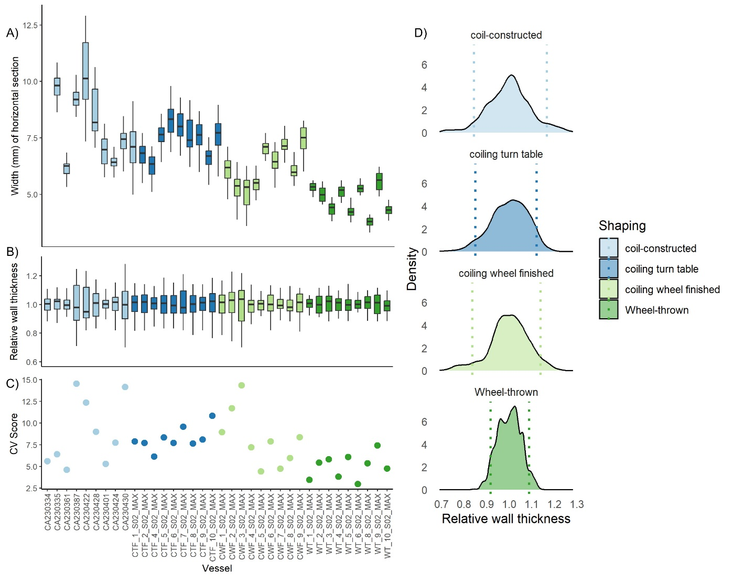

**Supplementary Figure 2.** The distribution of vessel wall thickness values calculated from horizontal sections of individual vessels made by different forming methods, grouped by those forming methods. Coil-constructed data from this study, all others from Thér & Wilczek (2022). A) The distribution of 200 width values taken sequentially for each vessel. B) The values of the widths divided by the mean widths for the vessel. C) The CV calculated from the 200 measurements for each vessel. D) Density plots for all vessels grouped by their forming methods, with the 90% range marked by the vertical dashed lines.

We observe similar intra-vessel variation on the samples that were made by coiling, coiling with turntable finishing, and coiling with potter’s wheel finishing (Supplementary Figure 2). Only the wheel-thrown vessels had significantly lower levels of variation in the thickness of their walls. This suggests that variability in horizontal sections is primarily capturing differences that arise from the primary method of forming.

**S3. Calculating CVs on dimensionless data**

Previous studies attempting to quantify variability in morphology from outline-based GMM data have calculated the CV from normalised PC scores (Wang & Marwick 2020; Loftus 2022; Smallwood *et al.* 2022). The need for normalised PC scores is described in Wang and Marwick (2020, p. 5) as necessary ‘given that CVs are most informative when computed on either all positive values or all negative values.’ They therefore normalised the values to range from 1 to 10. However, when normalising inherently dimensionless PC scores to all positive values, samples which have PC scores that were originally positive are shifted to be more positive and will have a higher normalised mean resulting in a lower CV score, while values that were initially negative will have a lower average mean, and thus a higher CV score and will be interpreted as having less standardisation. This can be demonstrated when examining data produced by Wang and Marwick (2020), which we were able to re-analyse because of their good practice in making it fully available on github. We use it to demonstrate problems with the method, not the data.

Following outline-based GMM, they observed modest morphological distinction between vessels made during the Pre-European, Post-European, and Chinese phases (Supplementary Figure 3). Vessels from the Chinese phase had positive PC1 scores and mostly negative PC2 scores, while vessels assigned as Pre- and Post-European phases ranged across both axes. In their assessment of the CV scores calculated from the normalised PC’s, they found significant differences in pottery shape and shape standardisation that indicated changes in pottery production resulting from contact with mainland Han Chinese groups in north-eastern Taiwan. They identified that the lower CV score in PC1 seen in the Chinese vessels (15%) compared to the higher variation in the earlier pre-European (33%) and post-European (31%) period vessels as indicating a trend towards standardisation in shape over time.

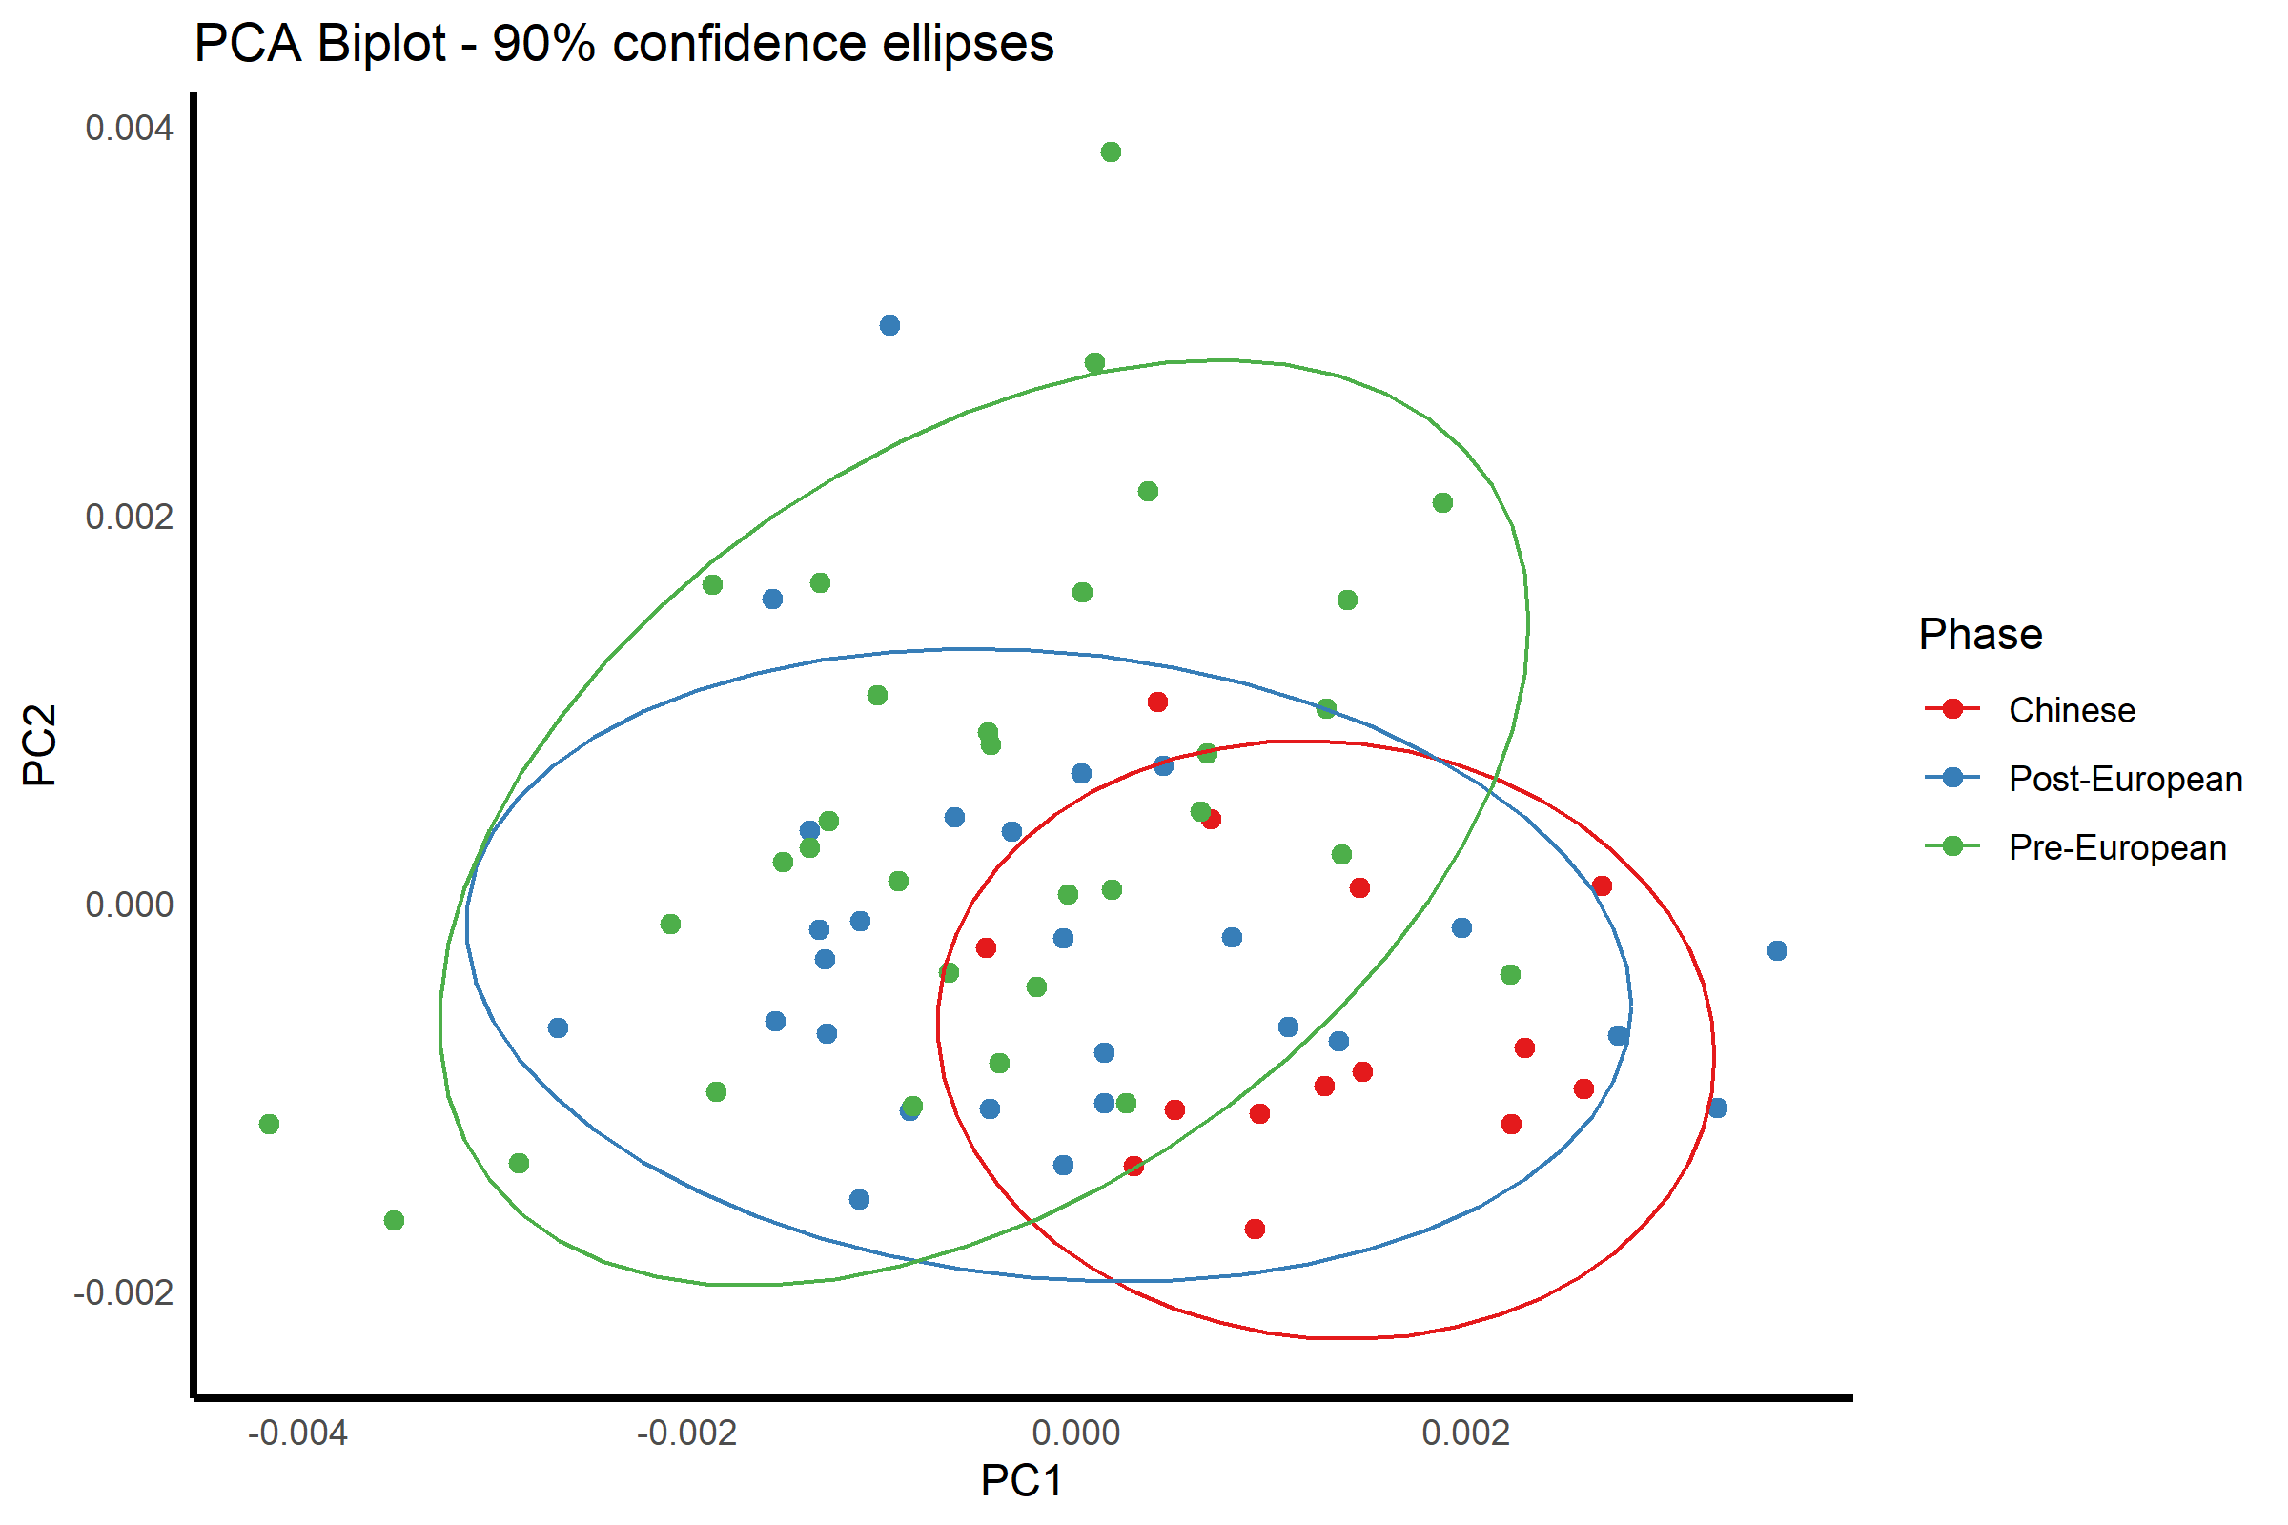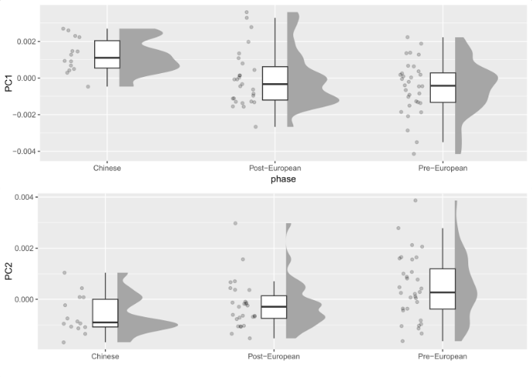

**Supplementary Figure 3.** (*Left*) Biplot of PC1 vs PC2 for samples from Wang and Marwick (2020) distinguished by phase with 90% confidence ellipses overlaid, and (*Right*) distribution of PC scores by phase.

However, if their original PC plots were inversed (Supplementary Figure 4), which would not change the interpretation of their morphology as PC scores are inherently dimensionless, the difference in CV would be much less pronounced (29% in the Chinese vessels versus 30% and 35% in the Pre- and Post-European period, respectively). They also considered standard, metric measurements when considering standardisation, and saw a much more modest difference in variation in body diameter between then Chinese (CV=8%) compared to the Pre- (CV=11%) and Post-European (CV=12%) vessels.

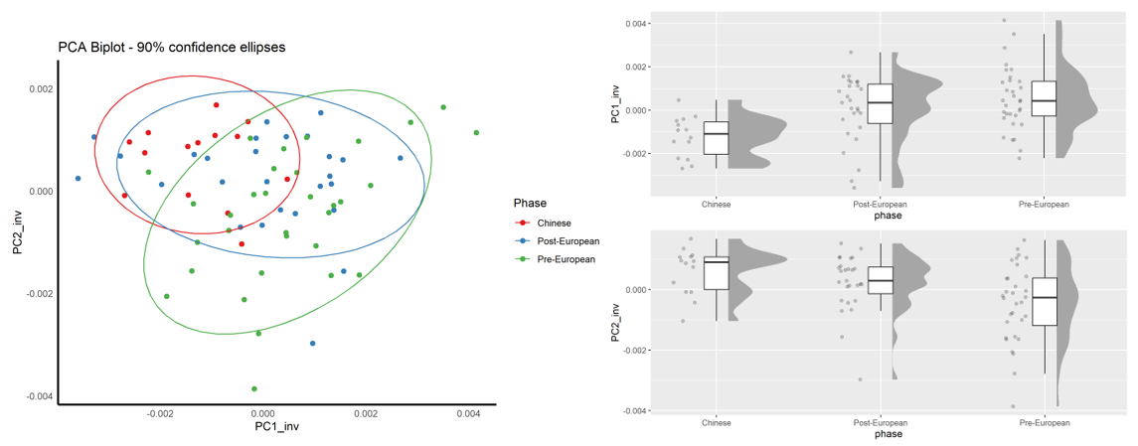

**Supplementary Figure 4.** (*Left*) Inversed biplot of PC1 vs PC2 for samples from Wang and Marwick (2020) distinguished by phase with 90% confidence ellipses overlaid, and (*Right*) inversed distribution of PC scores by phase.

We calculated the group distance to the centroid value (DGroup) for the samples in Wang and Marwick’s study and conducted a permutation test of homogeneity of multivariate dispersion (PERMDISP). This test consists of measuring the distance between all individual group members (vessels) and the group (phase) centroid in multivariate principal coordinates analysis (PCoA) space using the betadisper function of the vegan package in R (Oksanen *et al.* 2024). Groups (phase) with more variance will have larger mean distance to the centroid values (**Supplementary Table 3**). While the results suggest that the Chinese vessels showed modestly lower levels of variation having a lower DGroup value compared to the Pre- and Post-European phases, the results of the ANOVA showed that the differences in the dispersion of the vessels were not significant (F=1.3398, p = 0.2685).

**Supplementary Table 3.** The average distance to the centroid for each phase considering 48 PCs.

|  |  |  |
| --- | --- | --- |
| **Phase** | **Sample size** | **DGroup** |
| Chinese | 14 | .0159 |
| Post-European | 27 | .0196 |
| Pre-European | 32 | .0203 |

We hope this illustrates the problems of using normalised PC scores for calculating CVs in morphological analyses. Because PC scores are inherently dimensionless, normalising them to a fixed range introduces biases that can artificially inflate or deflate CV values depending on the original sign (positive or negative) of the scores. As shown with data from Wang and Marwick (2020), by simply inverting the PC axes, which does not alter the interpretation of morphology, we see substantial changes in the calculated CV values. We propose using DGroup as a more appropriate approach.

**References**

Caloi, I. & F. Bernardini. 2024. Revealing primary forming techniques in wheel-made ceramics with X-ray microCT. *Journal of Archaeological Science* 169. Elsevier Inc. https://doi.org/10.1016/j.jas.2024.106025.

IGAC. 2022. Base de datos vectorial básica. Colombia. Escala 1:100.000. . *Instituto Geográfico Agustín Codazzi (IGAC)*. <https://www.colombiaenmapas.gov.co>.

Klesner, C.K., rawford, R., Aristizábal Losada, L., Bernal Arévalo, M., Campos-Quintero, L.M., Cárdenas Arroyo, F., Maya Cabrera, M.C., Murillo Jaramillo, P.A., Pérez Fernández, D.A., Sáenz-Samper, J., Uribe-Villegas, & M.A., Martinón-Torres, M. 2025. Disentangling technological traditions: comparative chaînes opératoires of painted pre-Hispanic ceramics from Nariño, Colombia. *Open Archaeology*. doi: 10.1515/opar-2025-0038.

Loftus, J.F. 2022. Reexamining Ceramic Standardization During Agricultural Transition: A Geometric Morphometric Investigation of Initial - Early Yayoi Earthenware, Japan. *Open Archaeology* 8. De Gruyter Open Ltd: 1249–68. https://doi.org/10.1515/opar-2022-0273.

Mendoza Acosta, R. & K.H. Marín. 2023. Chronology and prehispanic Capulí funerary contexts in El Porvenir, municipality of Iles, department of Nariño, Colombia. 22. https://doi.org/10.21676/issn.1657-4923. https://doi.org/10.21676/issn.1657-4923.

Mendoza Acosta, R. & J.C. Rubin de Rubin. 2021. Formación geoarqueológica del sitio arqueológico El Porvenir, vereda El Porvenir, municipio de Iles, departamento de Nariño (Colombia). *Arqueología y Patrimonio* 2: 53–80.

Oksanen, J. et al. 2024. vegan: Community Ecology Package. *R package version 2.6-6.1*. https://CRAN.R-project.org/package=vegan.

QGIS Development Team. 2022. QGIS Geographic Information System. *QGIS Association*. https://www.qgis.org.

Smallwood, A.M., T.A. Jennings, H.L. Smith, C.D. Pevny, M.R. Waters, T.J. Loebel, J. Lambert, J. Ray & D. Stephens. 2022. Using 3D Models to Understand the Changing Role of Fluting in Paleoindian Point Technology from Clovis to Dalton. *American Antiquity* 87. Cambridge University Press: 544–66. https://doi.org/10.1017/aaq.2022.19.

Thér, R. & J. Wilczek. 2022. Identifying the contribution of rotational movement in pottery forming based on statistical surface analysis. *Archaeological and Anthropological Sciences* 14. Springer Science and Business Media Deutschland GmbH. https://doi.org/10.1007/s12520-022-01561-y.

Wang, L.Y. & B. Marwick. 2020. Standardization of ceramic shape: A case study of Iron Age pottery from northeastern Taiwan. *Journal of Archaeological Science: Reports* 33. Elsevier Ltd. https://doi.org/10.1016/j.jasrep.2020.102554.